**GIT command line example**

Name: Jikhan Jeong

Date: 8-26-2022

* **Downloads**

<https://git-scm.com/downloads>

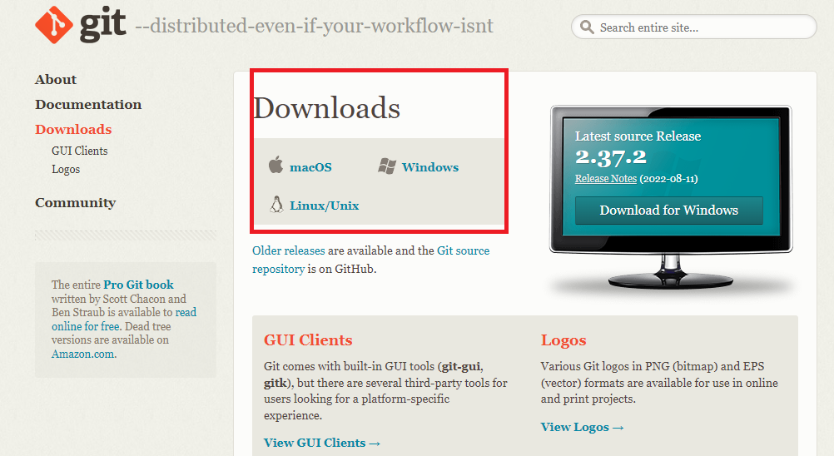

* **Click Git Bash**

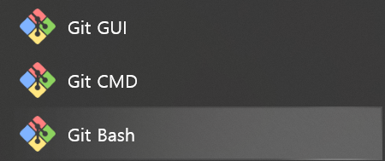

* **Command line practice**

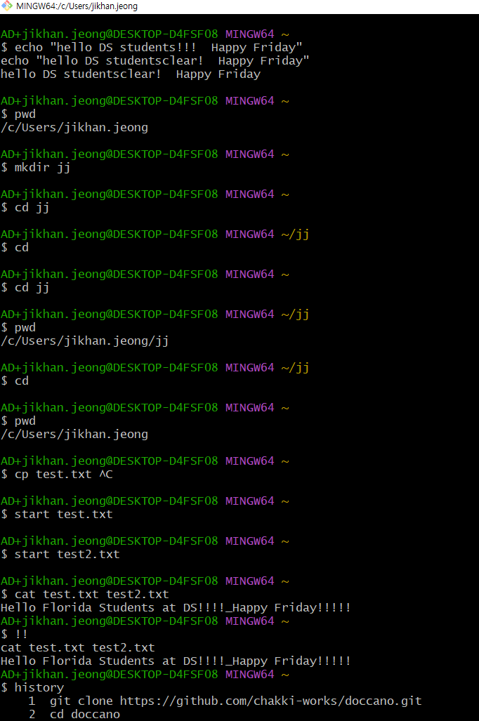

Code

*echo "hello DS studentsclear! Happy Friday"*

*pwd*

*mkdir jj*

*cd jj*

*cd*

*cd jj*

*pwd*

*cd*

*pwd*

*start test.txt*

*start test2.txt*

*cat test.txt test2.txt*

*cat test.txt test2.txt*

*history*

*exit*